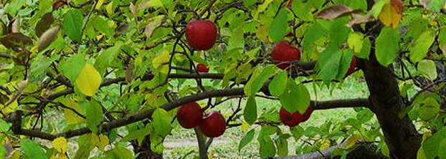
A Community
Orchard for Ide ?
Public Meeting: 7.30pm 18th January 2017
Ide Memorial Hall
Speaker: Charles Staniland,
Chair of Orchard Link
How can we protect the Victorian Orchard opposite Pynes Farm?
This meeting will consist of a 20 minute presentation from the Chair of Orchard Link (‘Saving Traditional Orchards’) followed by a ten minute public Q & A session.

A formal Ide Parish Council Meeting will follow this public meeting.

