PYNES COMMUNITY ORCHARD - A PROSPECTUS (3rd Draft)

Foreword

Ide has long been a village of orchards. Pynes Orchard is across the road from Pynes Farm, on the right as you go south up the hill out of Ide. It remains as one of Ide’s oldest traditional fruit orchards, currently neglected, yet still in its original form. Its 3.87 acres of sloping field, facing north, overlook the village. It is currently grazed by horses, and contains a number of old apple trees, some bent and resting on the ground. The Church Commissioners own Pynes Orchard and, stimulated by discussions about the Ide Neighbourhood Plan, they have agreed to sell it to the Parish Council for use as a community orchard.

There are over fifty community orchards in Devon. They have become popular as places for village communities to come together for seasonal events such as apple pressing, and they provide unique spaces for recreation, productive activity, and relaxation. Local, common, public space is something we are short of in Ide. Community orchards are a great resource for schools seeking outside classroom activities. They offer the chance to maintain and increase biodiversity, provide local fruit and to resist property development - Pynes Orchard has been formally designated for protection as Local Green Space in the Ide Neighbourhood Plan.

We have joined an organisation called Orchard Link which promotes the restoration and replanting of orchards in South Devon, by offering technical advice and support. In January 2017, Orchard Link’s chairman, Charles Staniland, addressed a public meeting in Ide about the benefits of community orchards. Real enthusiasm was expressed at the meeting for the idea of buying Pynes Orchard.

In November 2017 the Parish Council set up a Pynes Community Orchard Working Group to progress negotiations with the Church Commissioners, to plan a fund raising campaign, gather ideas for the use of the orchard which fit the needs of Ide’s residents, and review how best to manage the orchard, its trees and boundaries.

In March 2018, the Council successfully negotiated a price with the Commissioners of £17,000 per acre, plus reclaimable VAT, which is in line with an independent valuation by Rendells Surveyors commissioned by the Parish Council in April 2017. In further discussions with the Church Commissioners in May 2018, we agreed the principle of a binding a three year option to purchase,
2

starting on 28 September 2018 when the current tenant’s lease will expire. We feel confident that we will be able to raise the necessary funds in that three year period.

The Parish Council has instructed Foot Anstey, a law firm in Exeter, to act for it in the purchase.

Ide has a rare, once in a lifetime opportunity to acquire a piece of land which borders its residential area, and which holds a key place in the village’s heritage and history. It will be an area of open space, for the public’s enjoyment, where traditional fruit trees can be restored, planted and cultivated as a community effort.

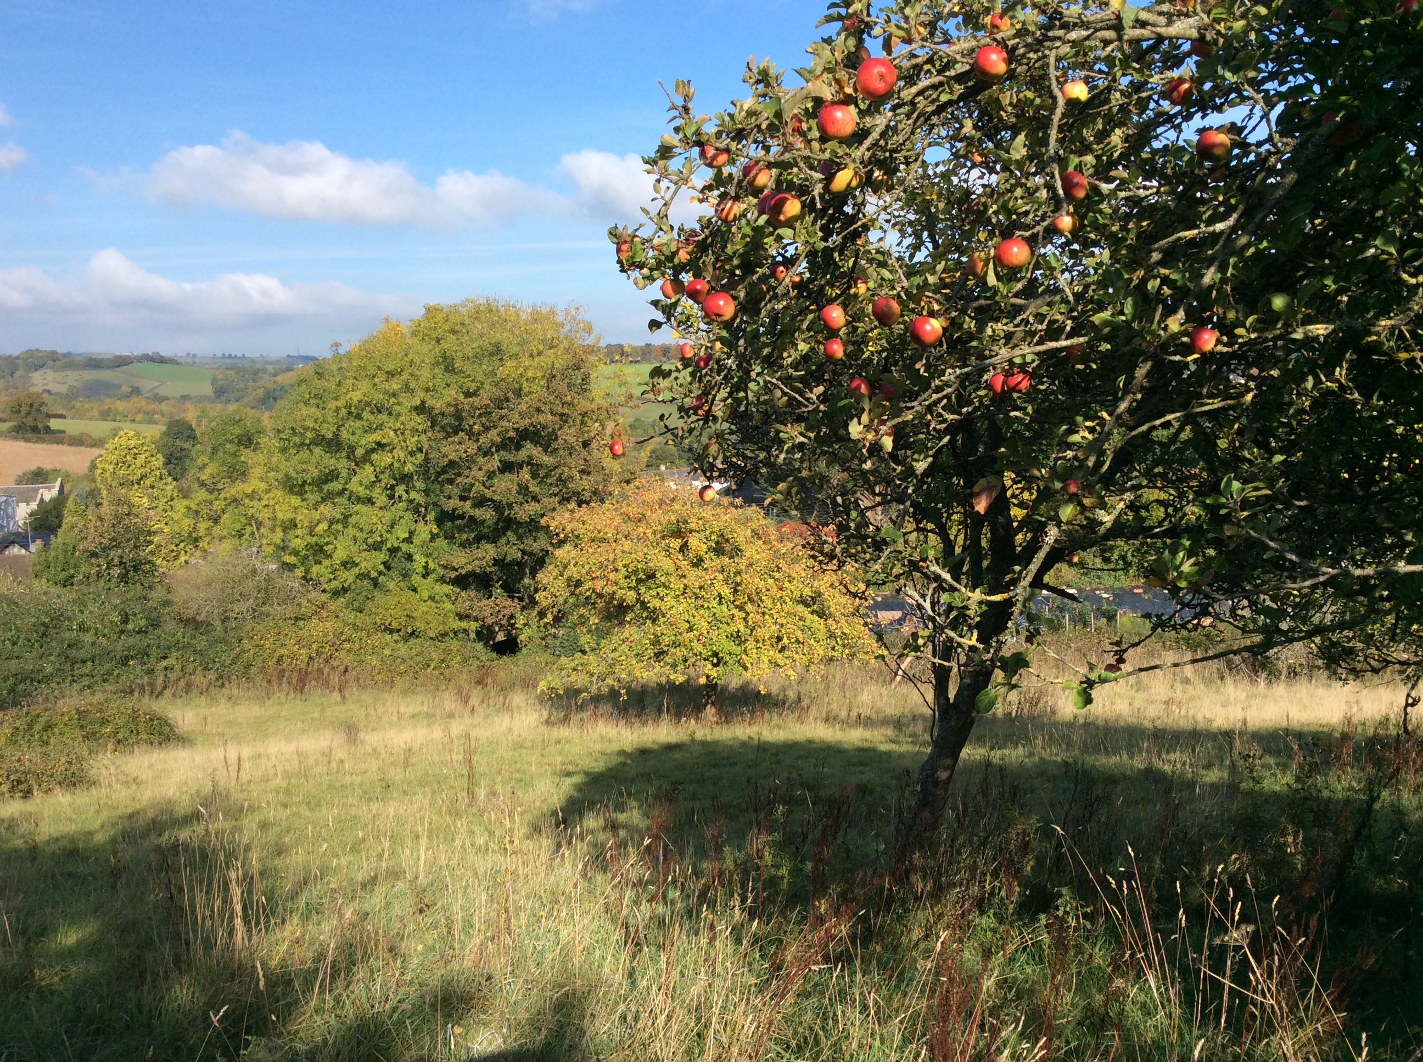

1 The Heritage

It is a sobering fact that since the 1950s Devon has lost at least 90% of its traditional orchards. Sadder still is that this figure is exceeded in our own village.

3

Traditionally every Devon farm had its own orchard, with historical taxation figures showing that in 1789 there were 22 farms of varying size within the village of Ide. Today there is one, and as the number of farms has declined so has the number of orchards.

Further evidence can be gained through a glance at the Ordnance survey maps of the early 19th century which clearly show the massive extent of orchard planting, and, by contrast, what has disappeared.

If one could have take an aerial snapshot of Ide in the spring of 1800 the village would have resembled a tiny island floating in a sea of pink and white blossom - a truly beautiful sight. There are of course remnants of this ocean: the strip of land behind The College; the paddock behind the Huntsman, and numerous solitary, gnarled and ancient apple trees in the back gardens of cottages and bungalows, barn conversions and houses throughout the village; and of course the largest of all, what we now call the Victorian Orchard, and which, when we have raised the funds to purchase it, will be redesignated as Pynes Community Orchard.

Originally part of Canns Farm, this orchard actually predates the Victorian era by several hundred years and could quite easily have been originally planted in medieval times. The fact that it still lies within its original boundaries adds to its historical importance.

The orchard was almost certainly planted with the production of cider in mind- a hugely important crop throughout Devon until the early 20th century with farm labourers often being paid in cider in preference to cash!

With its number of rare old apple trees it is not an exaggeration to state that historically this is one of the most important orchard sites in the county, which alone justifies our restoring and preserving it - an outstanding piece of landscape heritage for the whole community of Ide to cherish and enjoy for many years to come.

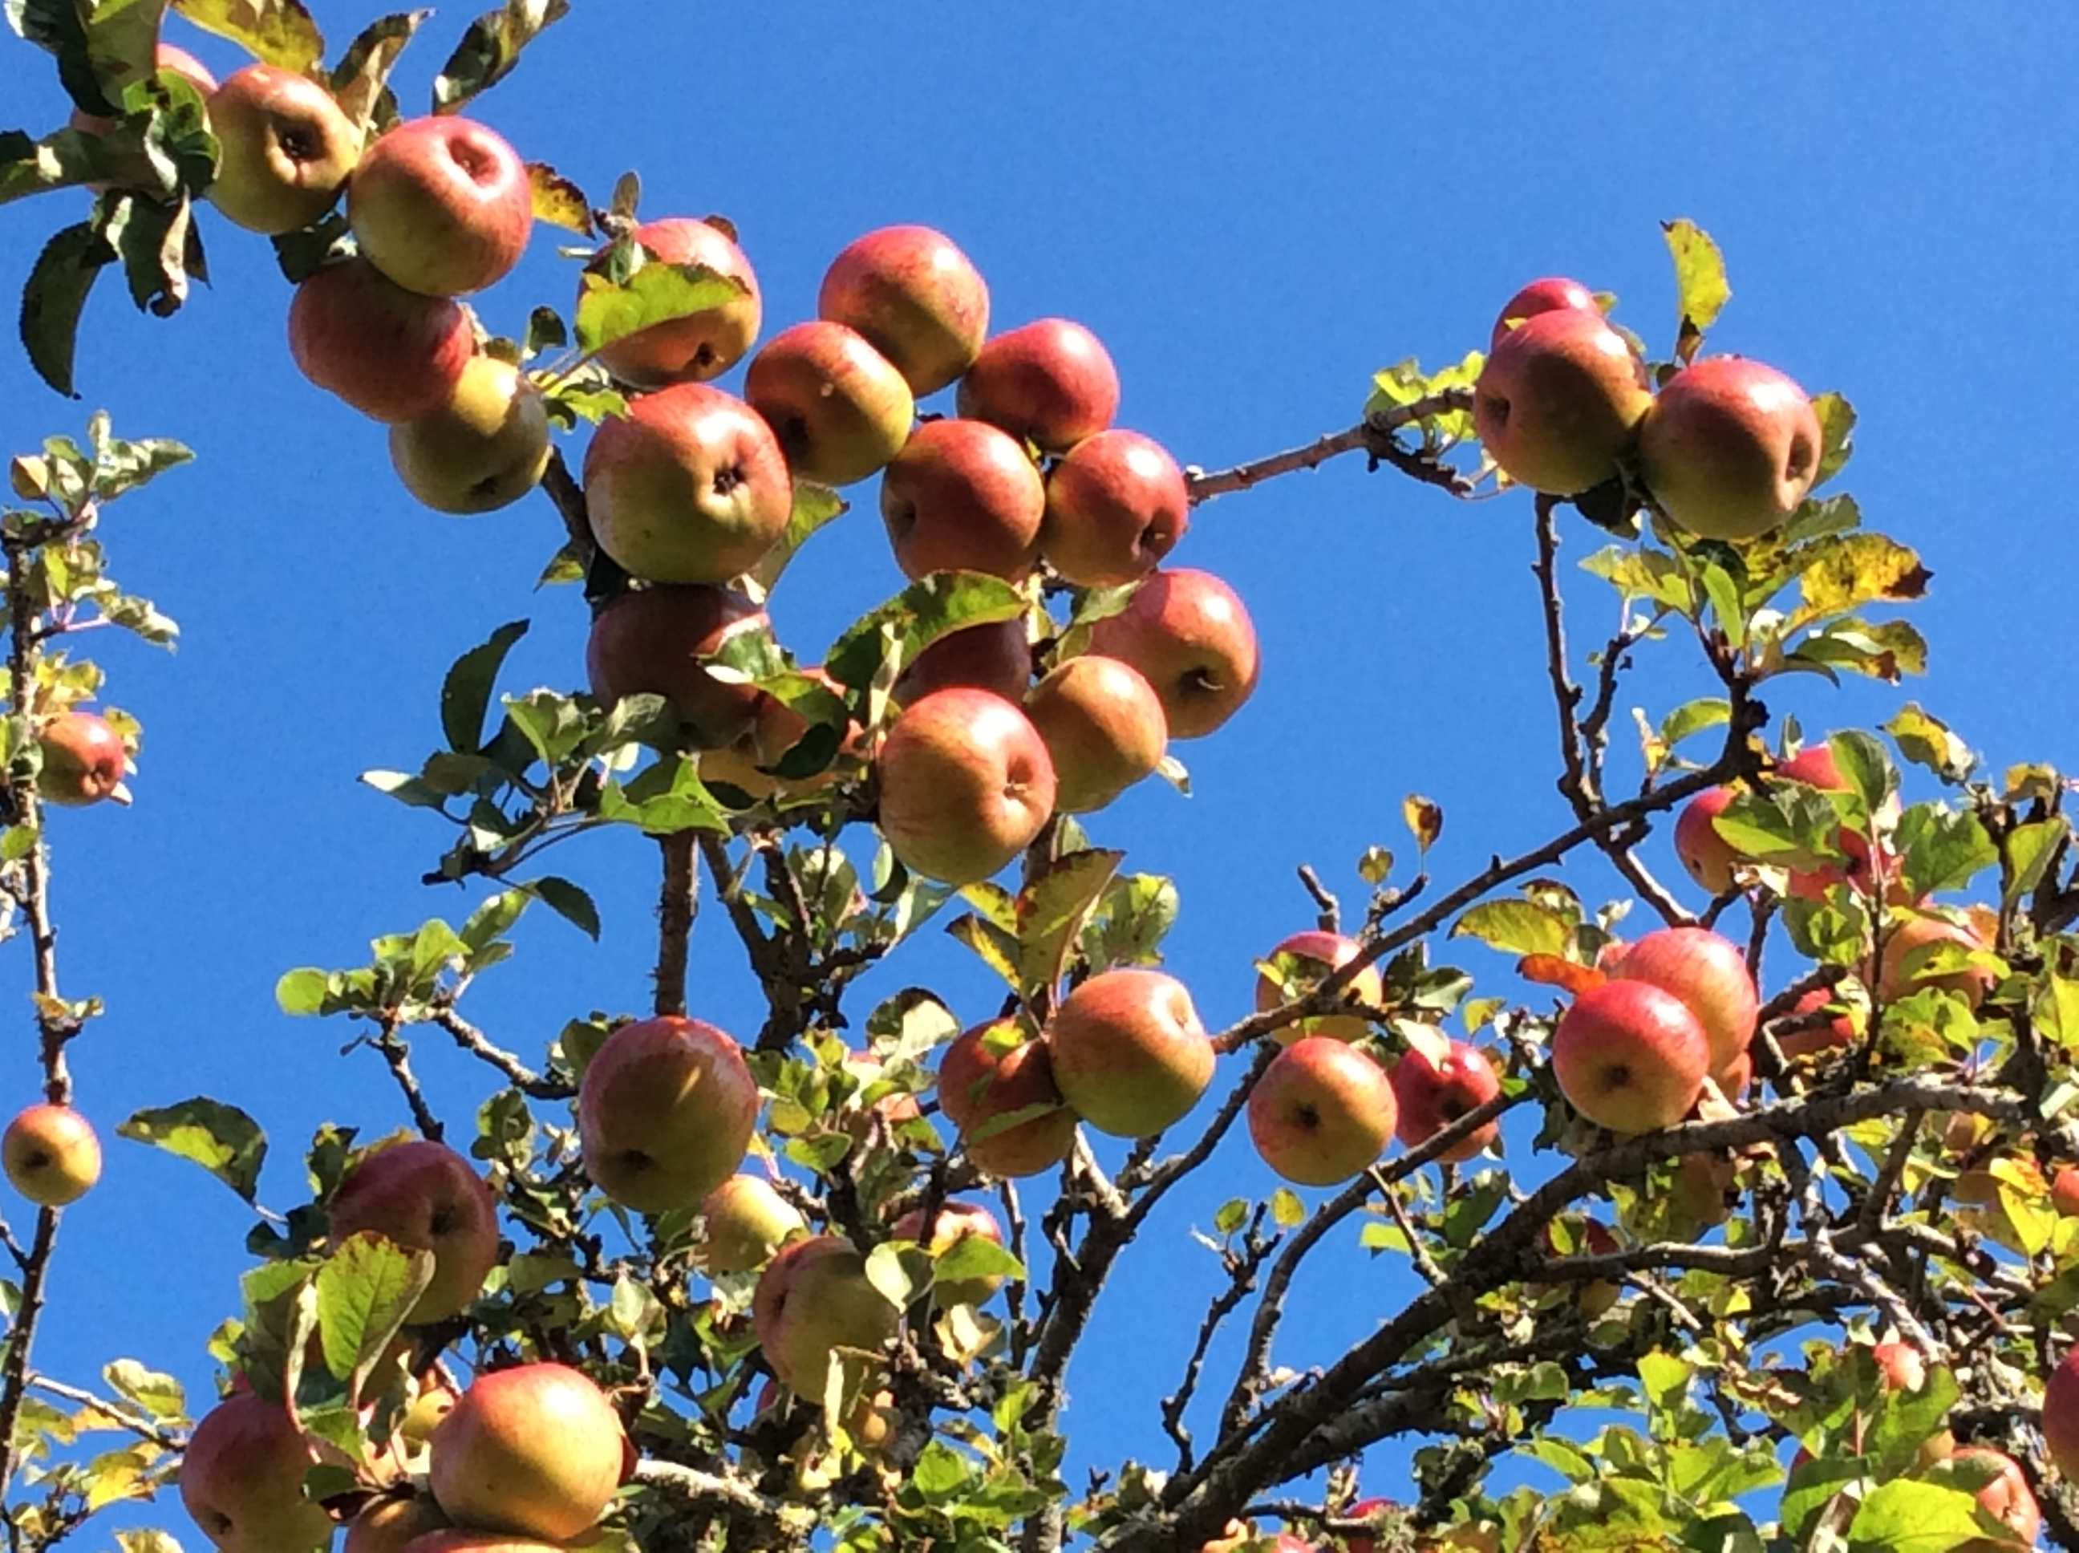

2 The Orchard and its potential for Cultural, Community, Education and Social Activities.

There is real potential for the Orchard to make a significant contribution to village life, providing opportunities for a diverse range of activities and benefits for the whole community.

Firstly, there are the obvious advantages of having our own orchard on our doorstep. While we are as yet a long way from discussing layout and design, we plan to restore and re-plant the orchard with apple and other fruit trees, with the aim of making our own juices and generating some income through the sale of the fruit.

We will work with local producers to share recipes and learn the traditional arts and crafts of cider making. We hope to make these events open to all, with talks and demonstrations; and to make sure the crop is good, we will tap into our folklore and bless the trees with a seasonal wassail!

Secondly, learning how these most natural of foods are grown and produced will present enormous educational properties for the children of Ide School, who will not only learn about the cycles of the seasons but also the importance of preserving natural diversity so that the apples and other fruits become pollinated. Each tree will also provide its own micro-habitat for an enormous number of species. Looking after the trees will also be an important part of Orchard life, and when the wood is pruned we will hold classes and workshops to learn how to craft this most natural material.

5

Finally, and maybe most importantly, the Orchard will create a natural open living space not just for nature but for all residents of Ide. The Orchard can become a sanctuary for restoring some balance with the natural world around us, for the benefit of us all. We plan to develop spaces within the Orchard for activities like yoga, tai chi and guided walks.

There will be great opportunities for new skills to be learned - hedge laying, pruning etc, and for social activities – picnics, wassailing, bonfire nights and cider, fruit juice and preserve making, as part of an annual calendar of activity.

3 Remedial and Restoration Work and New Planting

The Orchard has been neglected for many years. Until quite recently there were 40 productive apple trees in the Orchard - there are now thirteen. The remaining trees are interesting old varieties in their own right so a first task will be to carry out remedial pruning and care to help them to get back into production and to see what might be able to be salvaged from those that are bent or broken. There may be potential for up to 200 new fruit trees to be planted.

The surface of the Orchard is badly rutted and rough after at least two winters of horses being kept there. So the ground needs to be rolled and rested for a whole year, with a square metre cleared around each remaining tree to enable it to recover, and for the natural grass cover to reinstate itself. There is also work to do on the hedges and boundaries - some of which are broken down or overgrown.

But none of this is insurmountable and pretty quickly we will be able to begin to plan layout and the replanting of trees. We will be looking to re-establish the older, traditional varieties of apples, as well as planting pears and other soft fruit trees.

4 Environmental Considerations - the Orchard’s Habitats and Havens, Species Protection and Educational Use

A traditional orchard is rather different to an intensive modern orchard. It usually has had less management too, and is more akin both structurally and ecologically to wood, pasture and parkland habitat.

The diversity of habitats present typically include fruit and nut trees, grassland habitat and marginal scrub and hedgerow. Ponds are also often present as a water source for grazing livestock. Overall, the value of the sum of the habitats present is greater than the individual constituent parts as a wildlife resource.

6

To maximize ecological value old trees will be left with dead/decaying wood where it doesn’t affect tree health, as a specialist habitat for various rare beetle,
hoverfly and moth species. When we restock we will go for a diversity of local, traditional tree stock.

The underlying grassland habitat will be managed by a low level of grazing combined with cutting for hay, to maximize plant and invertebrate species diversity, with some apples being allowed to drop for winter birds. Winter migrants - fieldfares, redwings and hawfinches all feed on apple pips in wintertime, and, with the grassland protected and allowed to flourish, there will be an increase in the number of voles and the owls that feed on them. Protected species surveys will be undertaken.

We want village children and young people to see (and input) into restoring the orchard as a natural space which could tie in with Woodland school philosophy of Ide School.

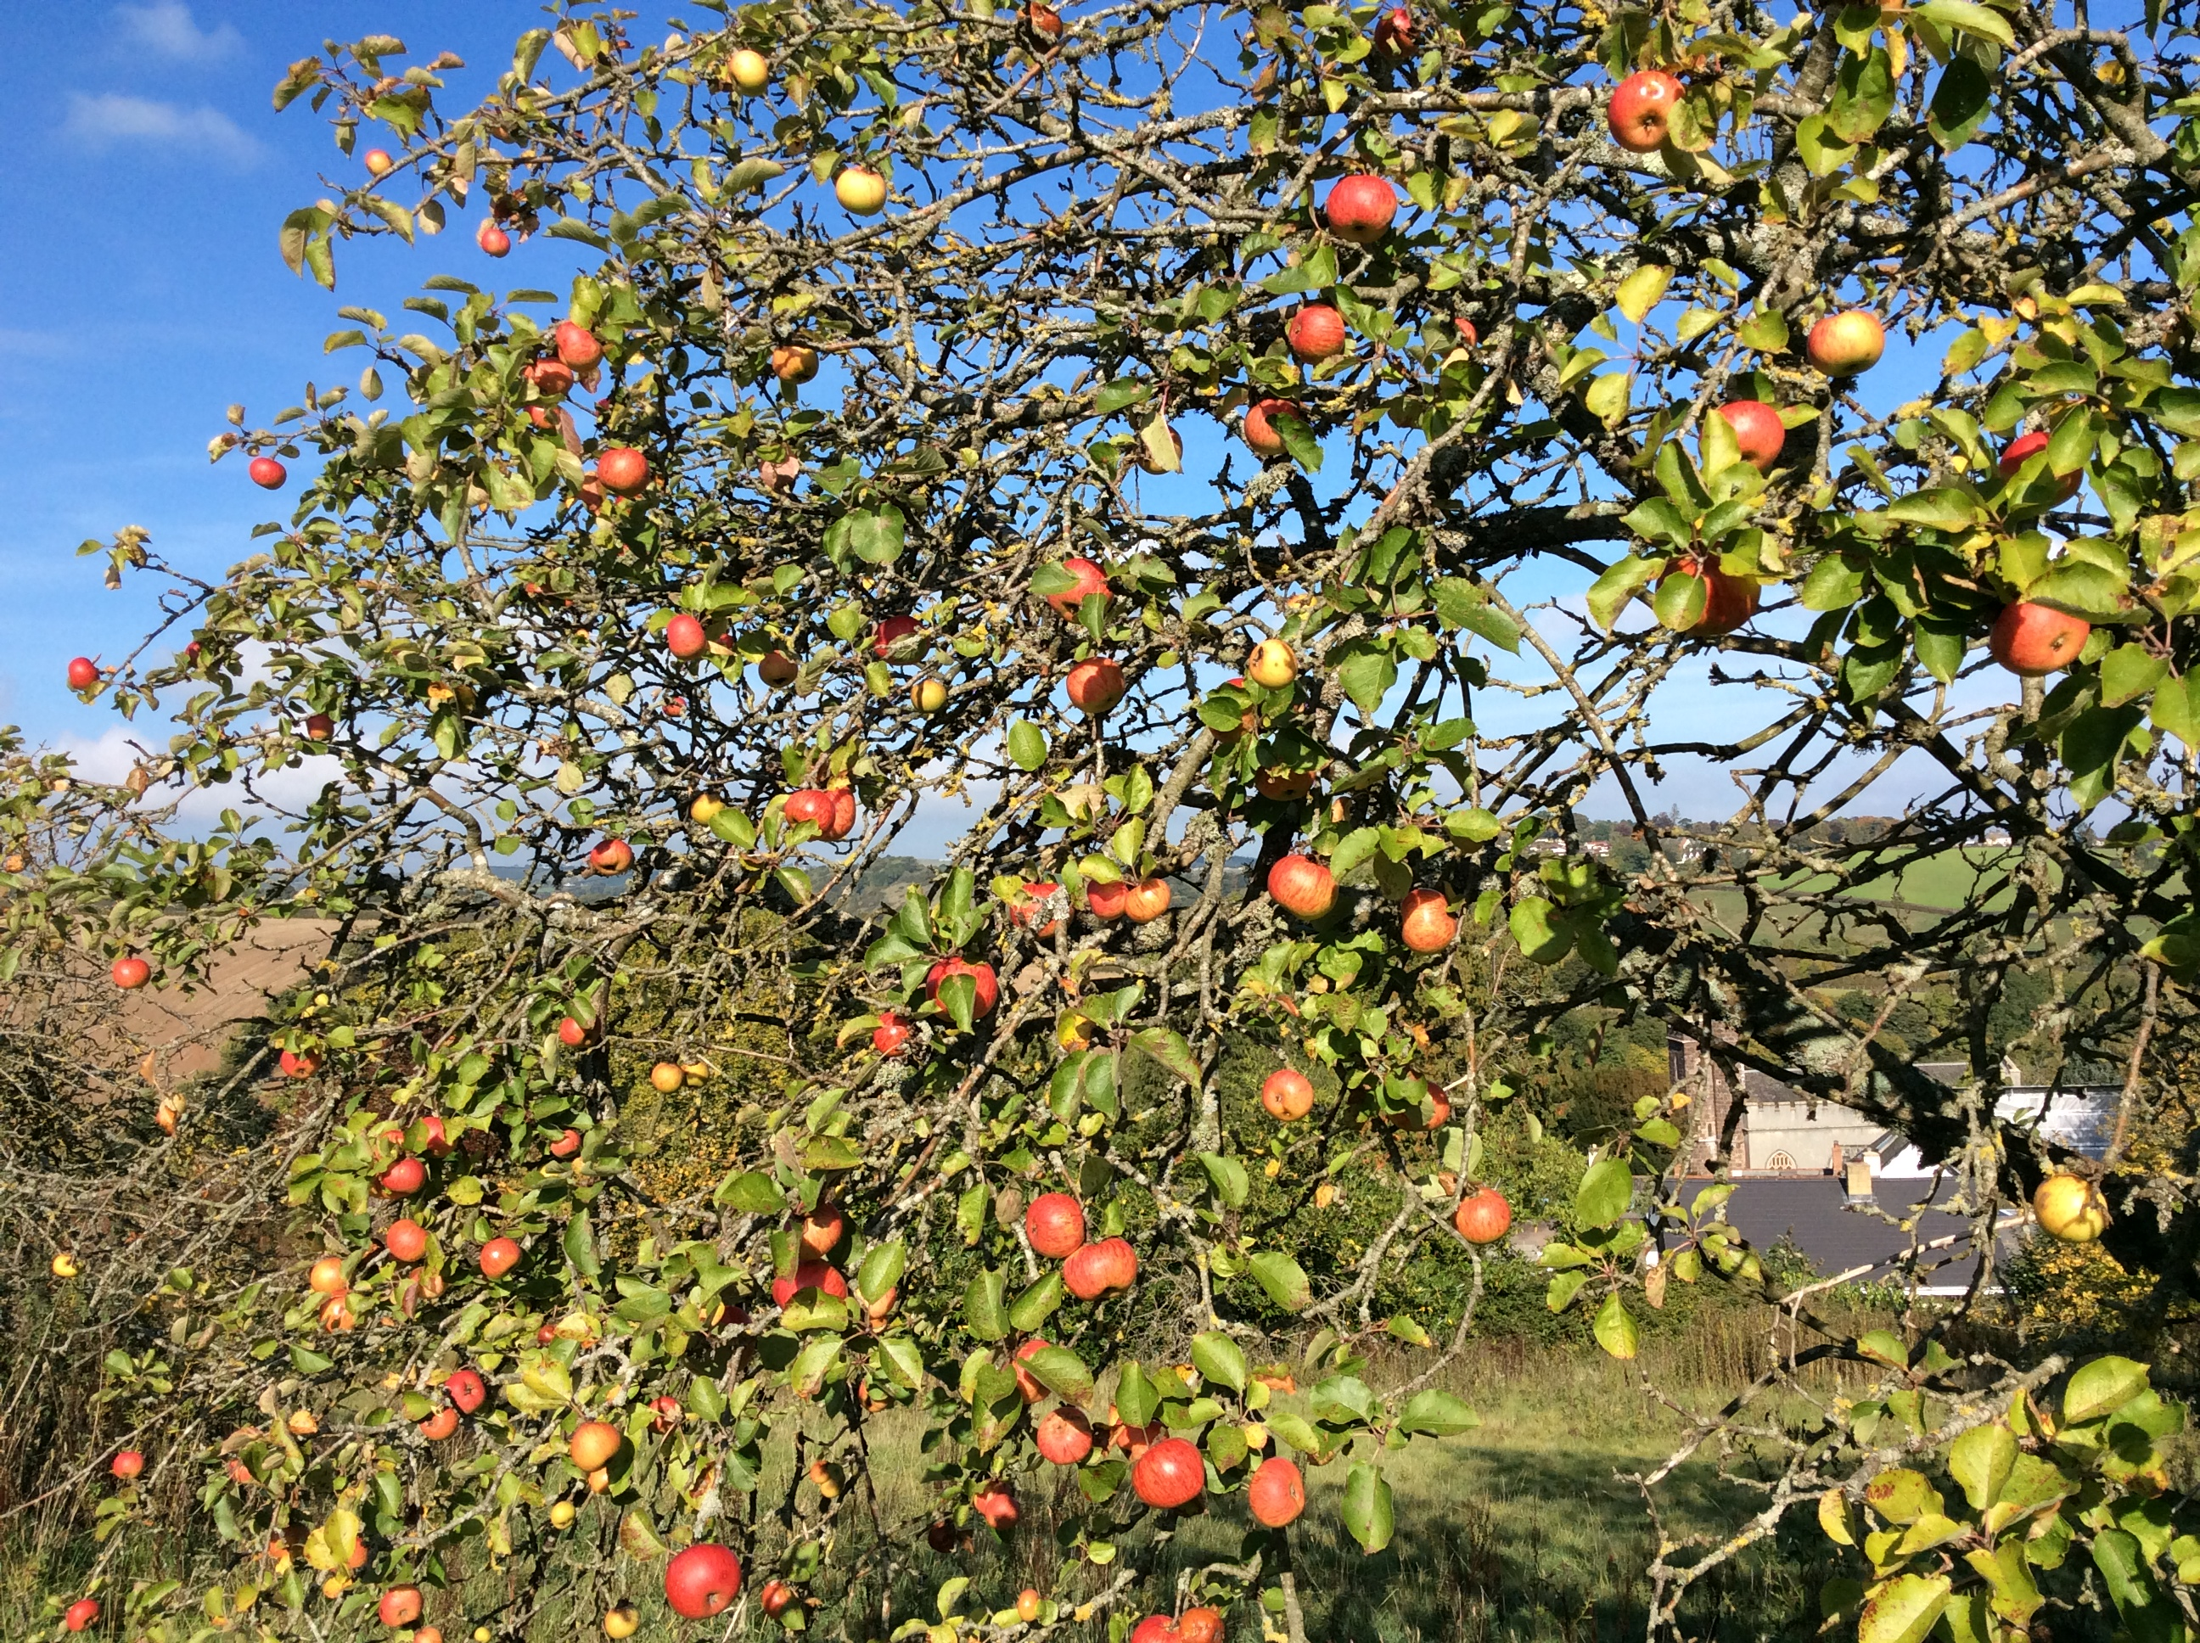

5 Financing The Project

The cost of the land will be £65,790 with reclaimable VAT of £13,150, and legal fees of around £3000, giving an initial purchase cost of circa £82,000. Additional funds - indicatively £10,000 - may be needed depending on the cost of work, new hedges, tree stock etc. A clear funding strategy is essential. The principles of this strategy will include:

7
- A broad based approach - in which a variety of strands will be adopted, that include - local crowdfunding and fund-raising events, together with charitable trust applications, to maximise the opportunities available
- A considerate approach - that recognises that in a vibrant village like Ide, there are always going to be competing demands for funding, so a considerate approach that prioritises funding opportunities, and works closely with other groups in the village also seeking funding, is essential.
There is a high level of interest and support for the Orchard Project within the village, and so it is hoped that a ground swell of energy and commitment will be harnessed to undertake fund-raising events, and to raise wider awareness and interest in the village over the next 12 months.

The Church Commissioners have indicated that they are willing to grant us a three year Option to purchase the Orchard with the potential of an annual licence during the Option period, to enable us to access the ground to begin restorative work.

Additionally, there may be individuals within the village, who might have a particular interest in the Orchard Project, and may be prepared to donate in various ways to the project, to guarantee the future of this historic site, as an open space and an ongoing established orchard.

Finally, there are various local, regional and national grant making charitable trusts that will be approached. An initial trawl of the funds available shows that there are many trusts whose criteria we meet.

Although there is a large fund raising target ahead, the Working Group is confident that this can be achieved. The goal of obtaining, sustaining and maintaining this established and historic orchard for the village of Ide for many generations into the future is therefore seen to be realistic and achievable.

6 Management of the Project

Ide Parish Council has set up the Pynes Community Orchard Working Group
(PCOWG) which has been meeting since December 2017. This group has brought together members of the Parish Council and members of the community with knowledge and expertise in horticultural and fruit tree management, agricultural knowledge, fund raising, and running community projects. Members are:

Peter Cloke Chair
Nick Bradley Ide Parish Council

8

Mark Thomas Ide Parish Council
Mel Liversage Ide Parish Clerk
Andy Bragg Agriculture and Orchards
Richard Sharman History and Heritage
Julian Perrett Environment and Ecology
Carolyn Tysoe Community and Allotments
Trevor Gardner Fund raising

A ‘Friends’ Group will be established as soon as our solicitors have tied up the necessary contracting arrangements with the Church Commissioners. This group will be open to anyone in the Community who wants to help with the Project in any way.

The Parish Council has oversight of the Project and receives regular reports at its meetings and communicates news, opportunities and updates via its website.

7 How You Can Help

The Pynes Community Orchard is for the whole community and so it is hoped that many Ide residents and those living in the surrounding area will want to support the project.

In particular we will be looking for people to get involved in these ways:
- Funding - would you be able to make a donation, to secure the orchard for the communities long term benefit?
- Do you know someone who might like to contribute?
- Would you like to volunteer your time and energy to work on preparing the orchard for its future community use
- Do you have expertise in managing trees, fruit harvesting, cider and juice making, land management, hedging, orchards, or any other related knowledge, skill or interest?
- Would you be prepared to organise a fundraising event in the village to raise funds for the community orchard?

We look forward to hearing from you, with your ideas, support and generosity

Contact:
Peter Cloke
Chair PCOWG
peter_cloke@btinternet Tel 07771 594726

3rd draft. Approved by Ide Parish Council on 25 July 2018

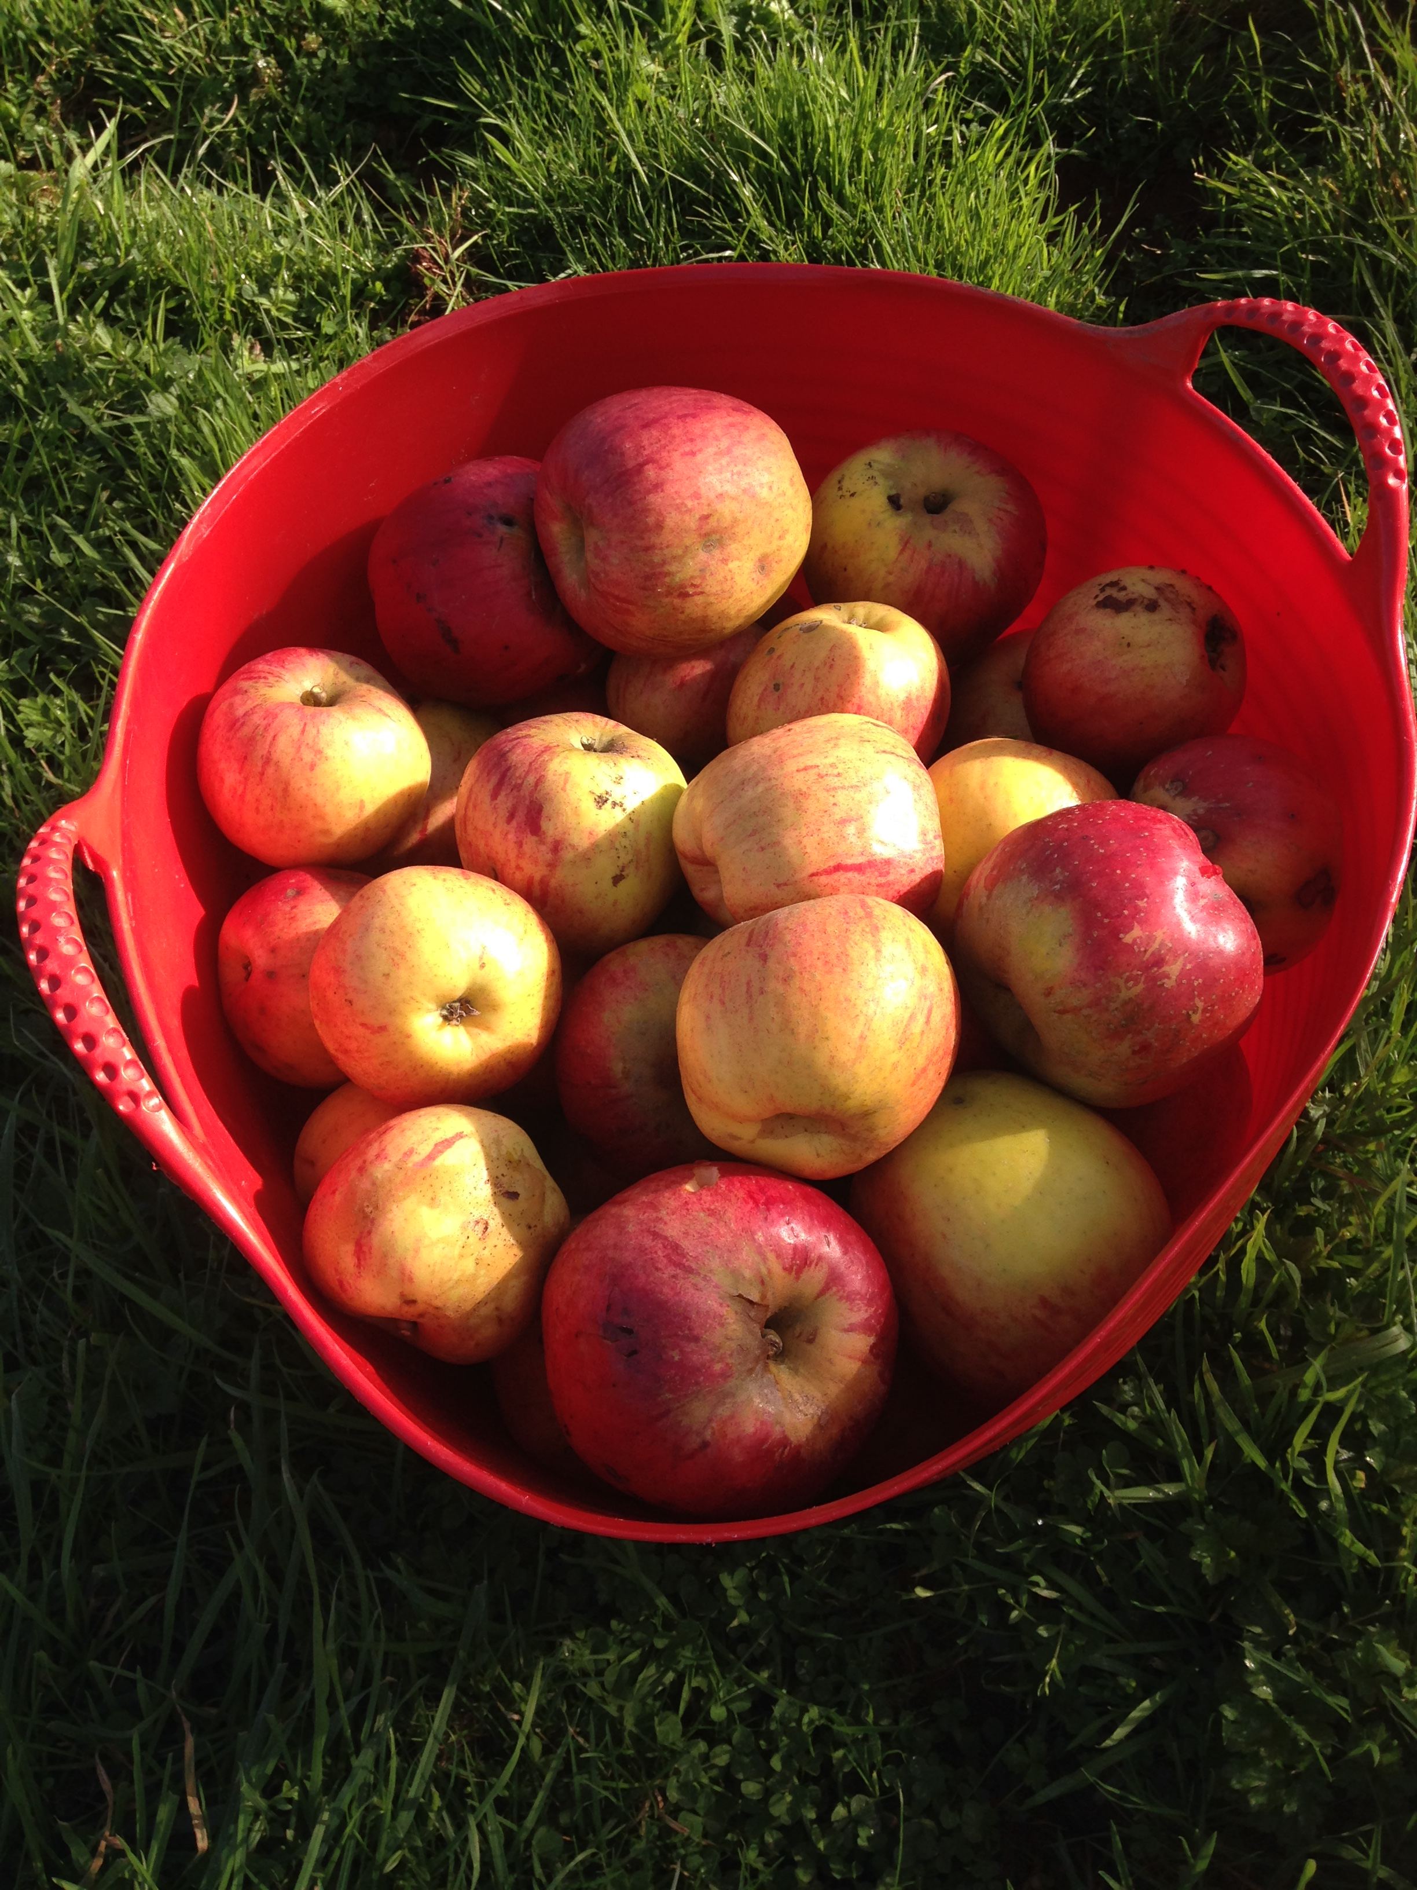

Appendix 1 Orchards in Ide at the beginning of the 19th Century

