Balls Farm Road and Little John's Cross Hill.

Report on illegal traffic following residents survey carried out by local councillors.
Updated with additional responses 5/6/18
Updated with additional responses and incorporating feedback 6/6/18
v4.0 9/6/2018

Andrew Swain, Ide parish Council
Assisted by
Alan Connett, Devon County Council
Peter Bishop, Ide parish Council
Safe Routes for ide, community group

For further information contact
Andrew Swain
bfr@stygian.org.uk
In a recent meeting with Devon Highways, Devon County Council, and members of Ide parish council, the problem of traffic using Balls Farm Road and Little John's Cross Hill illegally as a rat run was discussed. This has been a widely recognised problem for many years, but recent traffic surveys have shown that the volume of traffic has doubled since 2013.
Various options for management of the road were considered, but all the possible permanent solutions involve some impact on the residents. It was thought that residents had been consulted about the problem some years previously however no-one could produce any record of that survey or the results. It was agreed that the residents would be contacted again.
There is a group called "Safe Routes for Ide" which has been created by locals concerned about the issues facing those walking, cycling and riding on these roads. The group aims to work positively with all parties to protect the safety and amenity of walking and cycling routes in the Ide area. On 29 April 2018, a group of councillors and volunteers from Safe routes for Ide, carried out a survey of the residents in the traffic restricted area.

The area includes Doctors Walk, Little John's Cross Hill, Balls Farm Road, Crabbe Lane, and Saint Hill Close – highlighted in yellow in figure 1.

Fig 1, The area covered by the traffic restrictions highlighted in yellow.
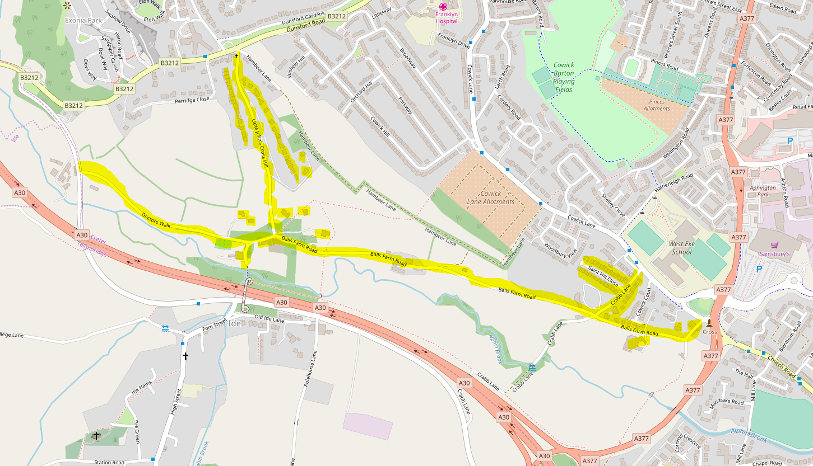
The electoral register shows 217 electors in the area covered, and a survey form was handed or delivered to each elector. We have identified 4 businesses operating in the area, and we provided a survey form to each full time member of staff in those businesses, a total of 31.

Forms remained anonymous except that the business ones were marked separately and residents were invited to offer contact details if they wanted to be kept informed.

The survey form
Traffic on Balls Farm Road and Little John's Cross Hill
There is an increasing number of drivers using Little John's Cross Hill and Balls Farm Road illegally as a rat run affecting residents, walkers, runners, cyclists and children going to West Exe School. A recent traffic survey shows that the volume of traffic has doubled since 2013 and most of it is using the road illegally.
Some members of Ide Parish Council are working with Devon county councillors, Devon Highways and the Police to find ways to address the problem, and we would like to hear the views of local residents.

Please could you take a few minutes to fill in this questionaire and help decide what could be done.
Please circle your the answers below
No – Maybe - Yes | Are you concerned about the traffic on these roads ?
No – Maybe - Yes | Do you think action should be taken?  If so, which of the following actions would you agree with?
No – Maybe - Yes | Should the Police stop traffic and advise drivers of the restrictions?
No – Maybe - Yes | Should the Police prosecute drivers using these roads illegally?
No – Maybe - Yes | Would changing the signs or restrictions discourage drivers?
No – Maybe - Yes | Would you be interested in a campaign group in the community focussed on this issue?
No – Maybe - Yes | Should the highways authority find permanent ways of controlling illegal traffic?
No – Maybe - Yes | Should it be closed to through vehicles?
No – Maybe - Yes | Would you want traffic calming?

Have you or your child experienced problems on these roads from other road users? Yes/No
If Yes, please give details

What do you think could be done to discourage drivers from using this illegally as a shortcut?

What do you think could be done to ensure that residents and businesses are not adversely affected?

Would you like to be kept informed by email of any further developments?
Email :

Further information
The traffic restrictions are "No motor vehicles except for access" on Balls Farm Road, St John's Cross, Doctors Walk and the Twisted Oak at all times. Only those accessing properties along these roads should drive on them. In addition there is a restriction of "No motor vehicles" at all using Doctors Walk between the C50 and the Twisted Oak, between 7am and 9:30am Monday to Friday.
Drivers can use Balls Farm Road and Little John's Cross Hill, to access the Twisted Oak pub and the Ide walking bus, but it is not legal at any time to use these roads to access West Exe School or as a short cut to avoid congestion on other roads.
The police are aware of the problem. If you need to report specific incidents, the Alphington team covering Balls Farm Road can be contacted via https://www.devon-cornwall.police.uk/your-area/teams/Alphington/Contact
Thankyou for your time and we look forward to hearing your views.
We will try to collect your questionnaire or you can return it to Ide community shop,
or you can contact us by email at bfr@stygian.org.uk

Response rate
The response rate was good with over 30% of forms returned.

 | Given out | Returned | Response rate
Total | 250 | 94 | 38%
Residential | 219 | 80 | 37%
Business | 31 | 14 | 45%

Response rate is high for an informal questionaire.

A surprisingly high number of people want to be kept informed with 44 responses offering an email address and requesting this.

Individual answers
The responses were surprisingly positive. The volunteers were prepared for a mixed response, including reservations about possible changes, but we did not in fact get that. The overwhelming majority absolutely perceive a problem and are pleased to see action on it.

97% answered yes to "Are you concerned about the traffic on these roads”?
93% "think action should be taken".
85% think "the highways authority [should] find permanent ways of controlling illegal traffic"
And 79% answered yes to "Have you or your child experienced problems on these roads from other road users?"

 | totals |  |  | percent
 | no | maybe | yes | no | maybe | yes
Are you concerned about the traffic on these roads ? | 2 | 0 | 92 | 2% | 0% | 98%
Do you think action should be taken?  If so, which of the following actions would you agree with? | 2 | 3 | 89 | 2% | 3% | 95%
Should the Police stop traffic and advise drivers of the restrictions? | 11 | 18 | 62 | 10% | 20% | 68%
Should the Police prosecute drivers using these roads illegally? | 7 | 14 | 72 | 8% | 15% | 77%
Would changing the signs or restrictions discourage drivers? | 36 | 28 | 26 | 40% | 31% | 29%
Would you be interested in a campaign group in the community focussed on this issue? | 19 | 24 | 45 | 22% | 27% | 51%
Should the highways authority find permanent ways of controlling illegal traffic? | 2 | 12 | 78 | 2% | 13% | 85%
Should it be closed to through vehicles? | 31 | 27 | 32 | 34% | 30% | 36%
Would you want traffic calming? | 9 | 24 | 57 | 10% | 27% | 63%
Have you or your child experienced problems on these roads from other road users? | 17 | 0 | 66 | 20% | 0% | 80%

Many residents felt that changes to the signage would not work. It was recently confirmed that all signs for the restricted area are in place and visible.

On the question "Should it be closed to through vehicles" response was mixed with 32 responding yes, 31 responding no and 27 responding maybe. This survey is only of residents of the restricted area: exactly the group of people who might be adversely affected by closure. Other relevant groups when considering permanent solutions include nearby residents needing a safe route for non-motorised traffic separate from the existing main roads, and the need for Exeter to maintain and improve its transport network as it encourages people to seek alternatives to driving.

Themes in Comments
References marked [x] state which individual response sheet the quote is taken from.

The most common theme in comments is speed of traffic, with 31% of responses mentioning this.
"Dog walking I am often frightened by the traffic going to excess speed and passing unecessarily close to me" [62]

21% mention that it is dangerous.
"In 2013 I was knocked over by a car while I was walking my grand childrens dog. I was taken to hospital by ambulance. Police involved" [76]
"Have to turn right into Balls Farm Road to access house, right on junction with tree & cannot see cars coming down hill – BLIND SPOT nearly caused crash" [36]
"Not a week goes by without a speeding driver narrowly missing our son who walks to school." [93]
"One of my sons was hit by a van, the other knocked off his bike and properly damaged." [92]

23% mention police enforcement in their comments
"Fine them" [24]

13% mention rude and abusive behaviour of drivers
"Drivers Swearing at me when turning into drive" [56]
"Refusing to reverse one person got out & locked his door & walked away" [51]
"I have been shouted at by a road user telling me to get my dogs off the road – this was in morning taking children to school." [16]
"They [my children] get verbal abuse from drivers. (I will no longer be walking along the road between 8 – 9am)" [91]

17% mention residents access by a gate or bollard.
"the benefit of controlling the traffic outweighs any adverse effects of closing one end of the road" [73]

Other comments
"This has been an issue for many years" [9]
"Hit by car; Pull vehicles out of hedge as passing very limited and fall onto our land" [6]
"Access along Balls Farm Road is slowed by constant oncoming traffic" [47]

There is evidence that people are deterred from using the road, which increases traffic on this and other roads.
"My son attends Ide pre-school and I don't walk in the morning due to the traffic." [63]

The problem also seems top be spreading with Crabbe lane route past Clarkes Pond also being used as a rat run.
"I would also like to add the road down to Clarkes Pond is being used more+more (always used to have barrier accross. Have seen cars using area like off road driving around there and motorbikes tearing through at speed. My dogs and I were nearly hit one day" [18]

Previous Traffic surveys

In 2013 this was already recognised as a major problem which had involved police and council action over the years before that, for example adding the additional restriction at Doctors Walk.

The peak time for students walking and cycling to school is 8:00 to 8:30. Survey results are for this time interval and given as the average vehicle rate per hour (VPH).

In 2013 our first traffic survey showed 76 VPH on Little John's Cross Hill and 70 VPH on Balls Farm Road. With 122 VPH passing the junction at the twisted oak tree on any of these roads.

In November 2017 over 6 days we saw 166 VPH on Little John's Cross Hill and 117 VPH on Balls Farm Road. With 228 VPH passing the junction at the twisted oak tree on any of these roads.

This is around double the rates recorded in 2013 and it was a significant problem then.
Surveys in the intervening years have shown a consistent steady increase.

In 2015 the community policing teams attended for several days and turned back illegal users, giving them a letter. This had very good results and traffic was significantly lower for more than a year. So much so, that we didn't do any surveys so unfortunately cannot prove the reduction. It has since returned to a higher level.

DCC have a policy to enable sustainable transport routes to and from the city. There are two large main road routes into Exeter for motorists entering the city from the south-west; and there is this safe route for users of sustainable transport methods, but it is being made unusable by the illegal traffic. The present situation means people are unwilling to use the route on foot or bike, and parents are unwilling to allow their children to walk or cycle to and from West Exe School, resulting in more car journeys on all the roads.

According to Highways' records, in the last 5 years there was one serious injury, or fatality on Balls Farm Road. Minor injuries and any other incidents including abuse of other road users are not counted in these statistics even if they are reported to the police, which many are not. Highways considered this low risk.

