PAPER 5
Current options for reducing or removing through traffic from Balls Farm Road
Introduction and background:
Balls Farm Road is a lane on the outskirts of Exeter that is rural that has essentially evolved from farm accesses over a period of decades, if not longer. The lane has never been ‘designed’, but over time has been encircled by urbanisation. Other, ‘designed’ roads are close by which take large volumes of traffic into and out of the main business and residential areas but as the volumes of traffic increase, so do congestion and waiting times in certain areas. This leaves some motorists looking for alternative routes to their destination.
For some time, there has been a perceived safety problem with vehicles using Balls Farm Road as a cut-through to avoid the congestion on Dunsford Road and Cowick Lane. It is thought that a lot of this traffic is accessing Balls Farm R0ad from the direction of Doctors Walk and Ide Lane, where there is currently a Traffic Regulation Order (TRO) in place restricting vehicular access, for any reason, between the hours of 07:00 and 09:30am Monday to Friday. This TRO is fully enforceable.
Balls Farm Road is especially sensitive to through traffic at the above times because of the presence of other vulnerable road users, especially young pedestrians and cyclists who are accessing West Exe School on Cowick Lane. There is also an equestrian facility that regularly uses Balls Farm Rd.
Other types of traffic include, but are not restricted to, local residents, deliveries and agricultural vehicles.

Collision History
Devon County Council looks at collision data over a 5 year rolling period to subjectively assess how well an area of highway is performing in terms of safety. When an area within a certain radius experiences 5 or more collisions over that 5 year period it would be subject to a review to assess whether interventions are needed to improve the safety of that section of highway.
The collision data is provided to Devon County Council by the police and only includes collisions that have caused slight, serious or fatal injuries. The police do not provide data on damage only collisions and these are not included in Devon County Council’s analysis.
The current data being used in this assessment run from January 2013 to December 2017 and show the following:
- 1 Serious Collision on 14th December 2013 at 16:40pm – This collision occurred between a vehicle and 1 pedestrian, who was recorded as an OAP, within the hours of darkness, with the weather conditions currently unknown.
In terms of safety review, this subjective analysis would suggest there is no current safety issue along Balls Farm Rd, especially at the times already included in the TRO.
That said, anecdote is often provided, about minor damage incidents, near misses and verbal abuse, by residents, highway users and other stakeholders. This is something the authority receives regularly, not just for Balls Farm Rd, but for many other roads around the county. Unfortunately, Devon County Council is unable to assess these reports objectively and therefore they cannot be included in the criteria to trigger a safety review and allocation of funding.

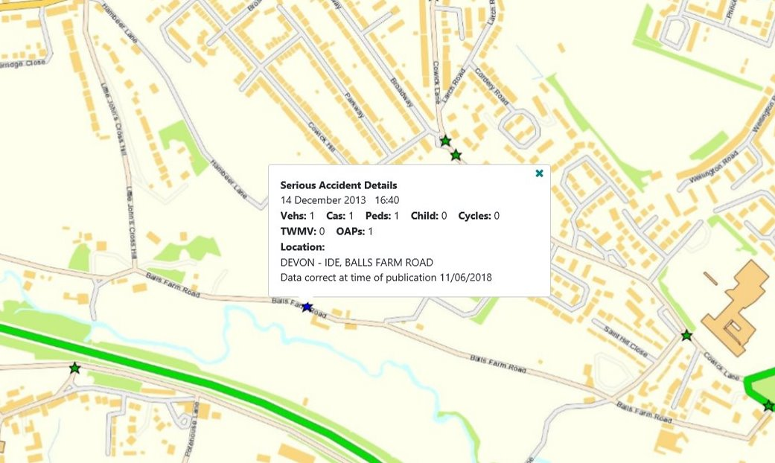
Balls Farm Rd Collision History Jan2013 – Dec2017
Site meeting and observations
On 12th June 2018 a site meeting was undertaken which was attended by:
- Cllr Yvonne Atkinson – Devon County Councillor Alphington and Cowick
- Cllr Alan Connett – Devon County Councillor Exminster and Haldon
- Dr Andrew Swain – Ide Parish Council
- Pete Bishop – Ide Parish Council
- Sgt Gary Phillips – Devon and Cornwall Police
- PCSO Ellen Holah – Devon and Cornwall Police
- PCSO William Malcolm – Devon and Cornwall Police
- Roger Haine – Devon County Council Highway Neighbourhood Officer
- Richard Brown - Devon County Council Highway Neighbourhood Engineer
The meeting commenced at 07:45am with the aim of observing traffic movements during the main travel to school period to assess the potential conflicts that were occurring.
The group were in position at the junction of Balls Farm Rd and Little Johns Cross Hill and it was evident that a steady stream of motorists were approaching the Balls Farm Rd junction from the direction of Doctors Walk. This would mean that they would have had to contravene the current TRO to get to that point. It appeared that upon seeing the group, some motorists opted to continue up Little Johns Cross Hill rather than use Balls Farm Road. However, some motorists still took this option.
There was also a steady flow of pedestrians proceeding down Balls Farm Rd having come from the Ide Lane footbridge direction, many of whom were of school age.
As a result of the observations it was requested that Devon County Council as the highway authority investigate some options to try and reduce the amount of traffic using Balls Farm Rd as a through route. It was also requested that Devon County Council assess whether it would be appropriate to install any of the options below as an Experimental Traffic Order (ETO) to see what the impact would be on the local area before make any such arrangement permanent. The options that have been looked at so far are described below, along with potential challenges that could prove to be barriers.

Traffic management options for Balls Farm Road.
- Creation of a No Through Road:
One option that would certainly reduce the through traffic using Balls Farm Road would be to close it at one end, whilst still allowing pedestrian, cyclists and equestrians to access it.
Although land has previously been offered to the council for the construction of a turning area, which would be required, this would still prove costly in terms of engineering to ensure the turn area is wide enough, and of suitable construction depth.
To combat this there may be an option to create a closure point at the junction of Balls Farm Rd and Little Johns Cross Hill. A barrier at this point may leave enough road space in Balls Farm Rd for vehicles to turn.
There is a private access which serves 3 properties and could be a way for motorists to bypass the barrier if this remained open. Initial discussions with one of the residents at the site meeting indicates that there may be a willingness to install a gate that only the residents can use to combat this. This would need to be confirmed with the remainder of the residents who use this access.
Other potential challenges to this option include:
- Public support – from the survey conducted by members of Ide Parish Council, 36% of respondents fully supported a closure to through traffic, with a further 30% saying they may be in support. With an overall response rate to the survey being 38% there could be only a small number in favour of the ‘No Through Rd’ option, therefore objection to future consultation could be high.
- Emergency services access – it would need to be confirmed whether emergency services would need access through the closed area. If so, removable features could be included in the design. However, these could not be lockable due to the need for keys, and therefore the access could be open to abuse.
- Agricultural vehicles – As there are agricultural activities along Balls Farm Rd it may be that the creation of the ‘No Through Road’ separates them from their land, forcing them to undertake longer journeys or find alternative methods of access. This in itself may prove unpopular.
In terms of cost, there would be an initial £3000 required for the processing of the TRO plus any cost required for the hard engineering and signing. Depending on the design this could be anywhere from £5,000 to £10,000. If during the consultation phase of the TRO process significant objection was received it could be conceivable that the project would go no further, as the cost to take the case through to public enquiry could be prohibitive.
It would be possible to install a ‘No Through Road’ as an Experimental TRO. However, many of the challenges mentioned above would still remain. The main difference here is that temporary measures can be installed on site whilst consultation for a permanent order is ongoing.
Initially the cost of processing the ETRO will still be £3000. However the cost of the engineering will be less at this stage as it will consist of temporary measures. That said, if the measures were made permanent the funding would still need to be found.
In terms of duration, an ETRO would normally be for a period of 6 months before assessing whether it should become a permanent measure, or be removed.

- No Entry to Balls Farm Road
Another option, which may reduce the engineering costs, would be to install a ‘No Entry’ to Balls Farm Road at the junction of Little Johns Cross Hill.
This would effectively act in the same way as the No Through Road, but without the need for a physical barrier, thus reducing any hard engineering cost element. It would however rely on some enforcement as there may still be a potential issue of abuse.
It is important to note that this would not be a One Way system. Residents on Balls Farm Road would still be able to drive in either direction, but no vehicle, including agricultural vehicles, would be able to legally access Balls Farm Road from Doctors Walk or Little Johns Cross Hill. The only exemption that could be made would be to cycles wishing to enter Balls Farm Road from Doctors Walk or Little John Cross Hill.
In terms of challenges, it may be that the same problems highlighted in the ‘No Through Road’ option are replicated here, especially in terms of public support, emergency services access and agricultural vehicles.
Again, this could be progressed under an experimental order with the same implications as before.

- Traffic Calming
This has been included as an option as the survey undertaken by Ide Parish Council indicated a desire from local residents to see some form of traffic calming. However, from an engineering perspective this may not be a suitable option for Balls Farm Road.
Firstly, the general purpose of traffic calming is to reduce speed, rather than traffic volume, and at present there is no indication of speed being a problem along Balls Farm Road.
Also, traffic calming measures, when not used for the intended purpose, could create greater problems. For example, when there is an increased amount of accelerating and braking between features, such as road humps, there can be an increase in engine noise and pollution. Larger vehicles, especially agricultural vehicles, will not favour such features and there may well be greater noise pollution when such vehicles encounter traffic calming, especially if towing empty trailers.
As Balls Farm Road is used by equestrians and cyclist a move to use traffic calming features may well prove unpopular with these groups.
In terms of cost, due to the amount of construction that would be required, this option could cost significantly more than the others mentioned.

Funding
At present, there is no funding available within current budgets to progress any of the options described above. If an agreed way forward was identified the next step would be to get the scheme onto a waiting list for future funds, whether it be from section 106 monies or other capital sources.
In order to achieve funding, and for the scheme to be successful, there should be as much support for it as possible along with plenty of prior consultation.

Report drafted by Richard Brown of Devon Highways Department, for the Safe Routes for Ide group
February 2019
For discussion at Ide Parish Council meeting 20 March 2019

