Briefing document for Ide Parish Council – Parking in the Hams
To be considered at Ide PC meeting on 20/11/19
Prepared by Andy Swain and Nick Bradley.

Abbreviations
Ide PC – Ide Parish council.
DCC – Devon County Council.
TDC – Teignbridge District Council.
TH – Teign Housing.

Key points
Ide PC and District councillors are not responsible for parking and have no direct control or influence over it. Councillors role should be in supporting all of our constituents and the community as best we can, including finding information and working with other parties to get the best outcome.
Some residents of the houses surrounding the grass square (outlined in blue) contacted Andy Swain in August 2019, wanting to get TH to turn the area outlined blue into parking. Andy Swain has not been able to find that planning consent has ever been applied for or granted.
There is genuine pressure on parking in the cul-de-sac of the Hams. Some residents sometimes park on the grass verge outlined in red. Some houses have off road parking and some do not.
Nick Bradley, Rachel Herbert and Andy Swain met with several residents of the Hams on site on 12/10/19, in response to questions from residents in relation to cutting the grass and parking on the verge outlined red.
TH have recently considered the request for parking in the blue outlined area and suggest instead seeking the creation of disabled parking spaces on the verges coloured red or orange.
There is currently a single disabled parking space in the corner between the orange and blue areas, as near as possible to the bungalows surrounding the blue outlined area.
It appears that current parking restrictions and habits are already making the best use of the space available. It is not possible, for example, to get a better outcome by parking differently.
All the areas shaded green on the attached map including the red, orange and blue outlined areas are protected as Local Green Spaces in Ide Neighbourhood Plan Policy Ide06.

Ownership of the land
The area outlined blue belongs to TH. TH initially thought the verges outlined red and orange belonged to DCC Highways, but a DCC Highways officer has checked and believes they are owned by TDC / TH. I am still awaiting a response from TDC legal department to establish which it is.

Map A

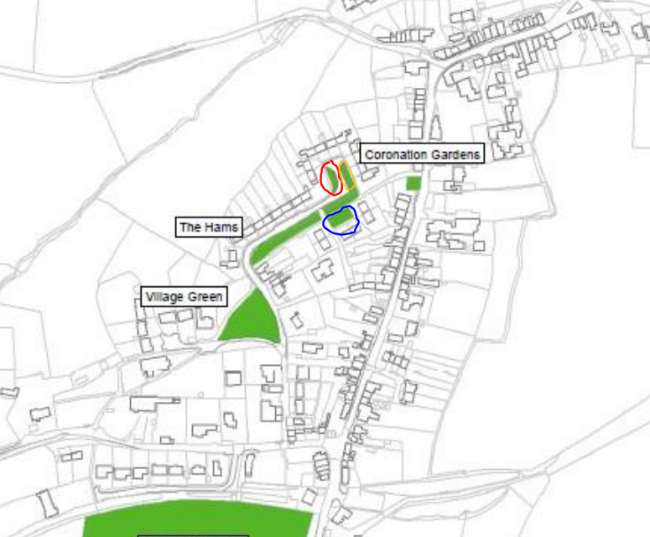

Planning approval requirement for creation of parking spaces
In some cases, planning consent may not be required if the hard standing is inside the curtilage of the property, and meets other requirements on area and drainage, for example porous surfaces such as the matting that supports vehicles but allows grass and other plant growth.
These verges are outside the curtilage of any property, so consent would be required.
Formation of parking spaces on the verge would require a dropped kerb which requires planning and funding. Without the dropped kerb, it would be legal to park on the road blocking the spaces.

Further information
For reasons of copyright, I include links to Google street-view rather than photographic images to illustrate the locations in question.
December 2008
https://www.google.com/maps/@50.7036611,-3.5599801,3a,75y,220.44h,61.08t/data=!3m7!1e1!3m5!1skOSN4uRA7emIuEvoF39VIA!2e0!5s20081201T000000!7i13312!8i6656
August 2012
https://www.google.com/maps/@50.7036455,-3.5599645,3a,31.3y,304.4h,67.69t/data=!3m7!1e1!3m5!1sBhjBkhu3CmfINLaX-Y52dw!2e0!5s20120801T000000!7i13312!8i6656

The final adopted version of the Ide Neighbourhood Plan is available at http://idevillage.org.uk/wp-content/uploads/2015/10/Ide-Neighbourhood-Plan-MADE-VERSION-September-2018.pdf
Chapter 7 relates to Local Green Spaces.

