Nick Bradley From: Peter Cloke
Chair Ide Parish Council Chair Pynes Community
Orchard Working Group

Date: 5 January 2020

Pynes Community Orchard - Progress Report

- The Orchard continues under the tenancy of Andy Bragg. During the summer and autumn months Andy kept the grass under control with a small group of cows and calves from Westown farm.
- It was not possible for all the apples to be collected this year. A small quantity was sold to juice and cider makers via the Orchard Link website, with the major part of the crop benefitting winter migrating birds.
- An initial plan for the layout of the site has been prepared to include picnic, recreational and wildflower areas. The Prospectus for fund raising etc is ready to go.
- Fifty new trees - mainly apple but with a few pear trees - have been planted this morning by members of the Working Group and villagers, with space for another thirty or so. A pruning and clearing day will be held next Sunday 12 January with details promulgated on the Orchard and Village Facebook sites.
- Progress with our Option to Purchase agreement with the Church Commissioners has been frustratingly slow, due to the still unresolved issue regarding the title to the dismantled railway to the rear of 78 High Street.
- The Parish Council will be aware from my briefing note of 16 September 2019 that a claim for adverse possession to this land was made by Peter Bishop on May 9 2019. Further correspondence between the Church Commissioners and Mr Bishop indicated that the legitimacy of the claim would appear to have been accepted and it is now a question of agreeing the terms of transfer - on the basis of either a possessory or absolute title.
- It is to be hoped that all parties will appreciate the need to get this resolved without delay. While this issue remains outstanding no progress can be made on securing our Option to Purchase agreement.
- Whilst we continue under tenancy arrangements, members of the public are unable to access the Orchard apart from participating in working group days.
- I am grateful to members of the Pynes Community Orchard Working Group (PCOWG) for the quality of their contributions, their forbearance and patience, and for their financial support for ongoing work in the Orchard.
- You and I have discussed Parish Council representation on PCOWG. We had originally agreed three reps, which reduced to two, including yourself, so may I invite you to nominate a further representative. We do our best to arrange meetings to accommodate individuals’ commitments.

Peter Cloke

peter_cloke@btinternet.com

07771594726

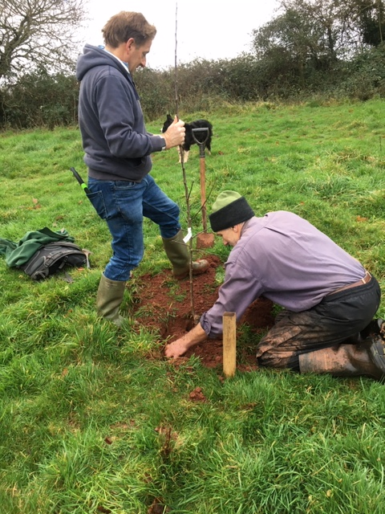

Andy Bragg and Trevor Gardner planting the first apple tree

