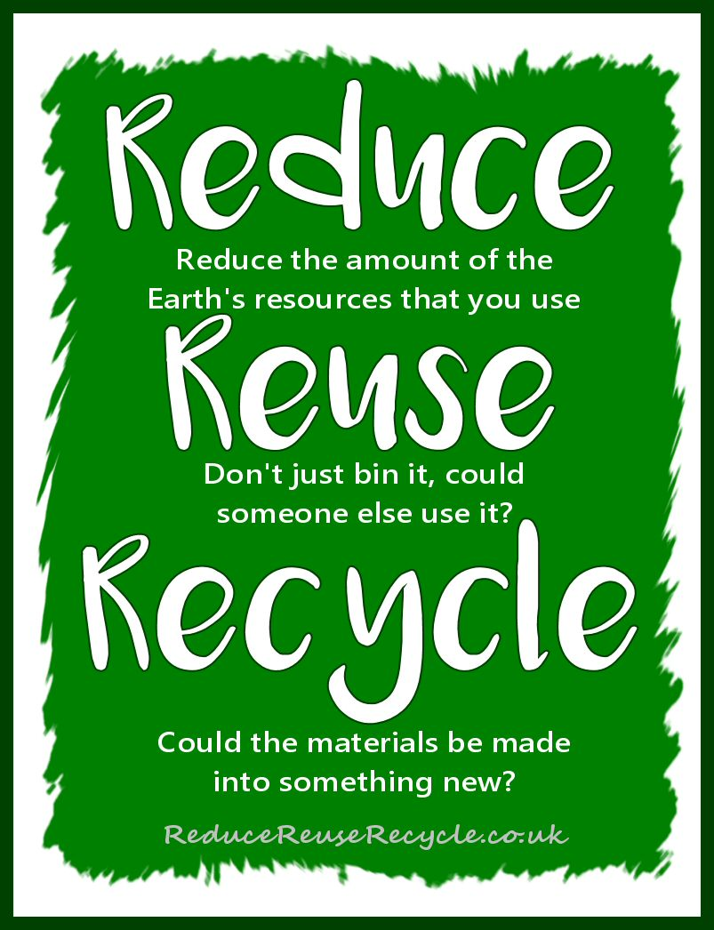
There’s a very good reason why ‘reduce’ and ‘reuse’ were chosen as the first words in the phrase above. Before we think about recycling anything, the very best thing that we can do for the environment is simply to use less resources in our daily life.
We live in a consumer driven society where we are continuously encouraged to think that the purpose of life is to Buy More Stuff. Yes, we have to buy some stuff, but there are many ways in which we can minimise the amount we buy and the resources we consume. The aim of this pamphlet is to provide information about the services, organisations and individuals that can help us reduce, reuse and recycle in our area.
REDUCE, RE-USE, RECYCLE in that order!

REDUCE
When you buy, think about……
- why you’re buying it - do you really need it?
- what you’re buying - is there a more sustainable alternative?
- where you’re buying it from - can you buy second hand, upcycled, or from a more local source such as Ide Shop?
Think about ways of cutting down your use of resources such as water, electricity and other fuels
All of these are not only good for the environment but are usually good for your bank balance as well. For example the department of energy suggest that you can save 1% of your heating bill for every degree that you turn down your thermostat.

RE-USE

Repair/maintenance | Exeter Repair Café – every third Saturday 10am-1pm at St Sidwells Community Centre, Sidwell Street, Exeter: small household items, (e.g. blenders, toys, heaters, fans ), laptops and electronic devices/IT issues, clothing items and accessories (e.g broken zips, hemlines) and larger electrical items such as TV’s. Donation for service.  Not operating again yet but you can email to check on the current situation. E-mail exeterrepaircafe@gmail.com  Men in Sheds – will mend Garden & DIY tools. 29 Paris Street, Exeter (Age UK) Shop telephone: 07769 591602 for details of opening times and drop-off arrangements.  Ride On - weekly workshop session where you can maintain your own bike with mechanics on hand to advise. 61 Haven Road, Exeter, EX2 8DP.  E-mail: info@rideoncycling.org
Donate to charity shop or social enterprise (where item sold at low cost/passed on to people on very low incomes) | If the item is in a good condition and someone else would be willing to pay for it – donate it to a charity. Those closer to Ide include:  - various shops on Cowick Street, St Thomas  - Reuse shop – at (Exeter Recycling and Refuse Centre ERRC), Exton Road, Marsh Barton (nothing electrical),  - the large Hospice Care, 2 Trusham Road, Marsh Barton.  For more specific items:  Bikes – donate to Ride On, 61 Haven Road, Exeter, EX2 8DP  Books – Book-Cycle, West Street, Exeter website book-cycle.org for details of opening  Furniture/white goods/carpets – Turntable, the Warehouse, Swan Yard, Okehampton Street contact via website www/turntable.org.uk or 01392 202032.
On-line swapping sites | Facebook sites:  - Exeter Journey to Zero Waste – can post if have bulk/specific items to re-use  - Exeter Area Trading, Selling, Swapping and Free page  Gum Tree
Set-up your own swap | Clothes swap, plant swap, etc

RECYCLE

ERRC, Exeter Recycling Centre, Marsh Barton, Exeter
April – September: Monday - Friday 9-5, Saturday & Sunday 10-6
Oct-March: Monday - Friday 9-4;30, Saturday & Sunday 10-4:30
TerraCycle is an innovative recycling company that has become a global leader in recycling hard-to-recycle waste. Go to website to browse the drop-off locations for different items near you. Typically set up and managed by a single person or a small group of people (known as administrator(s) they do change quite often so checking regularly is advised.
Item | Where | Other info
Aerosols | ERRC (Exeter Recycling and Refuse Centre, Marsh Barton)  Sainsbury’s Alphington* | Empty only  * Not currently in use but recycling in other supermarket carparks is available
Air freshener | Nourish, 56 Fore Street, Topsham
Baby food pouches | Exeter Library TerraCycle collection
Batteries | Household collection Green Box  ERRC  Sainsbury’s Alphington* | Car batteries can be recycled at ERRC
Beauty products | Terracycle | www.terracycle.com
Beverage & drinks cartons (tetrapak) | ERRC
Bicycle inner tubes | Exeter Bike Workshop 17 Market Place, Exeter
Biscuit/bar wrappers  Bottle pumps/trigger | Terracycle | www.terracycle.com
Bottle tops (plastic) | Household collection Black Box
Bread bags | 1st Heavitree Rainbows c/o amykellaway7@gmail.com | Terracycle collection
Bubble wrap
Cans | Household collection Black Box  ERRC  Sainbury’s Alphington*
Candles | The Recycled Candle Company, Candle Shop,  16 Gandy Street, Exeter 01392 307020 | Including tea lights in cases
Card/cardboard | Household collection Green Box  ERRC
Carpet | ERRC
CD/DVD/videos | DCW Polymers, EnvironHub, Marsh Barton, EX2 8NN | recycle a wide range of large plastic items. Visit website for details dcw.co.uk
Cereal boxes | Ide Facebook collector – Andrea Elisabeth-Smith | Recycles a range of packaging materials
Computers | ERRC
Confectionary tubs | Seasonal collection | www.terracycle.com
Contact lenses | Boots, High Street, Exeter
Crisp packets | Real Food Store, Queen Street, Exeter  Ellies Fund – BTRS Charity Fund | www.terracycle.com
Electrical items (big & small) | ERRC
Foil and foil trays | Household collection Black Box
Duvets | Gabriel House, Smythen Street, Exeter | Can be dropped off any time
Green waste | Household green bin (opt-in chargeable service)  ERRC
Glass | Household collection Black Box  Sainsbury’s Alphington*  ERRC (including window glass)  Spar, Dunsford HIll
Inhalers | Participating pharmacies Complete the Cycle Scheme
Laundry packaging | Nourish, Topsham
Light bulbs including fluorescent tubes | ERRC
LPG/gas bottles | ERRC
Make-up containers | Broadclyst address | Terracycle
Metal | ERRC
Mobiles | Oxfam, South Street, Exeter or via ‘fonebank’ | www.fonebank.com/oxfam?Is=oxfam
Oil (including cooking) | ERRC
Paper | Household bluesack  ERRC
Paper coffee cups | Sainsbury’s Alphington*
Pens | Ellies Fund – BTRS Charity Fund  Ellies Fund – BTRS Charity Fund | www.terracycle.com
Pet food pouches
Plant pots | ERRC
Plastic bags, cereal bags, freezer bags & plastic film | Sainsbury’s Alphington*
Plastic bottles, yogurt pots | Household collection Black Box  ERRC
Printer ink cartridges | ERRC
Shoes | ERRC,  West Exe Childrens Centre (by entrance)
Textile/clothing | Household collection | Put in carrier bag and leave with recycling.
Tins | Household collection Black Box  Sainsbury’s Alphington*  ERRC
Tools - garden | Men in Sheds – Next to Exeter Bus Station | Shop telephone: 07769 591602
Toothbrushes | ERRC – electrical
Toothpaste tubes | TerraCycles Oral Care Recycling Programme | www.terracycle.com
White goods | ERRC
Wine corks | By post to: Recorked UK, 11 Cornerhouse Lane, Widnes, WA8 9WD
Wood | ERRC
Water filter cartridges | Sainsbury’s Alphington *

