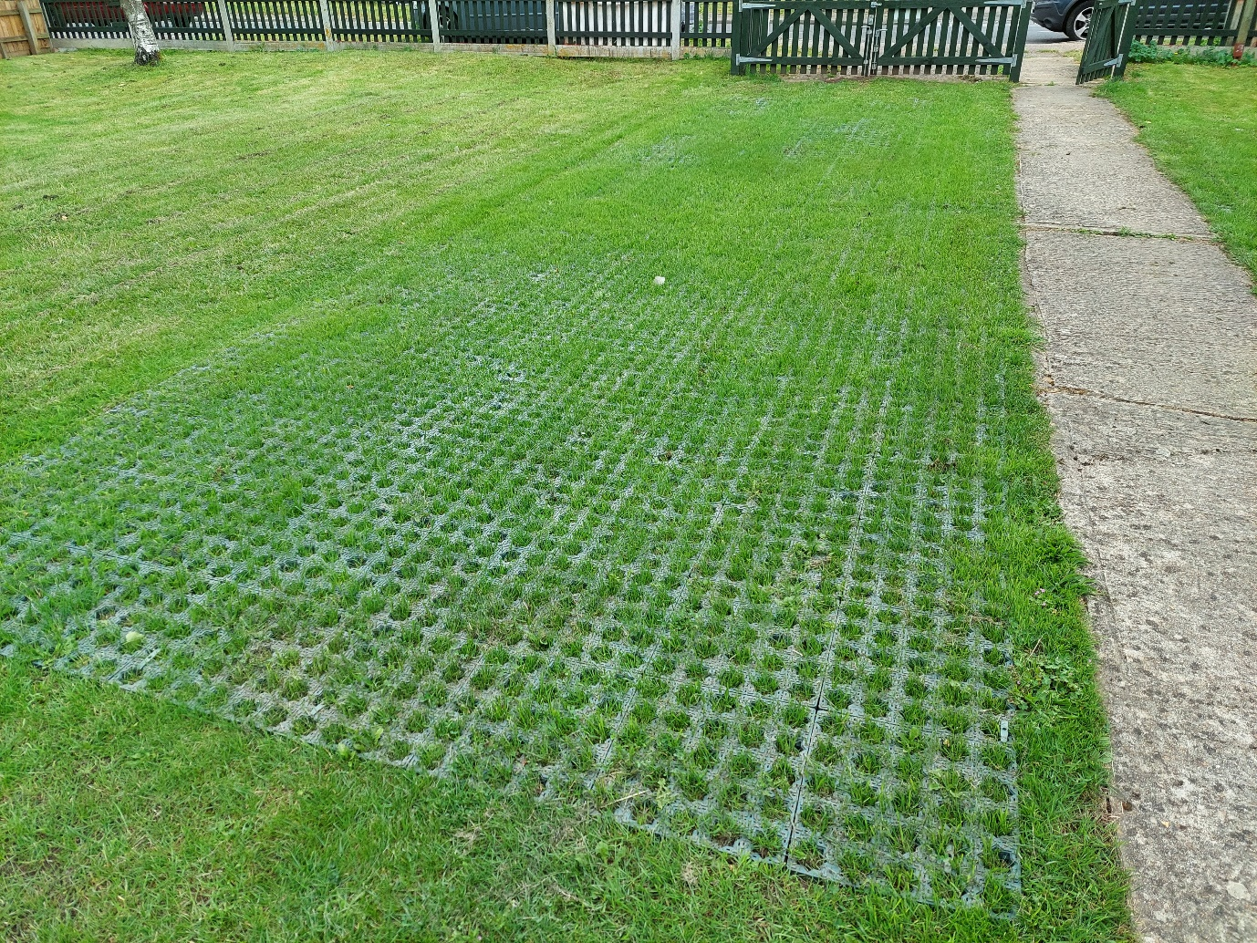
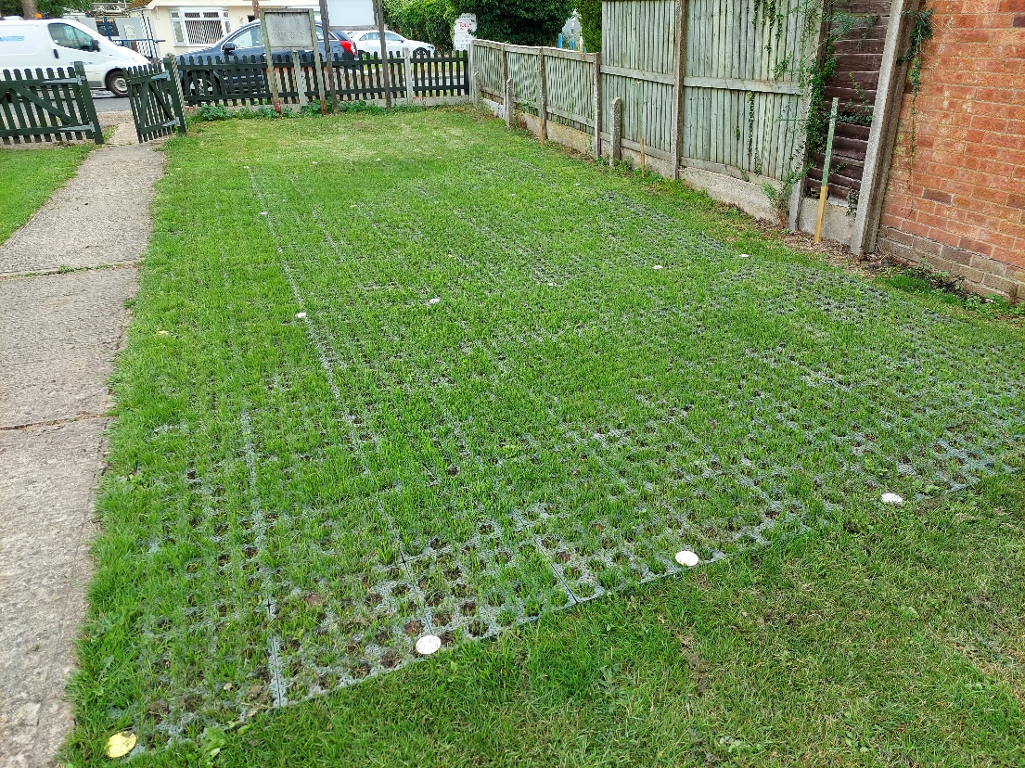
Gridforce IR35 - 34th Colchester Scout Group
Installed 10th July 2021 – photographs taken three weeks later at first grass cutting

