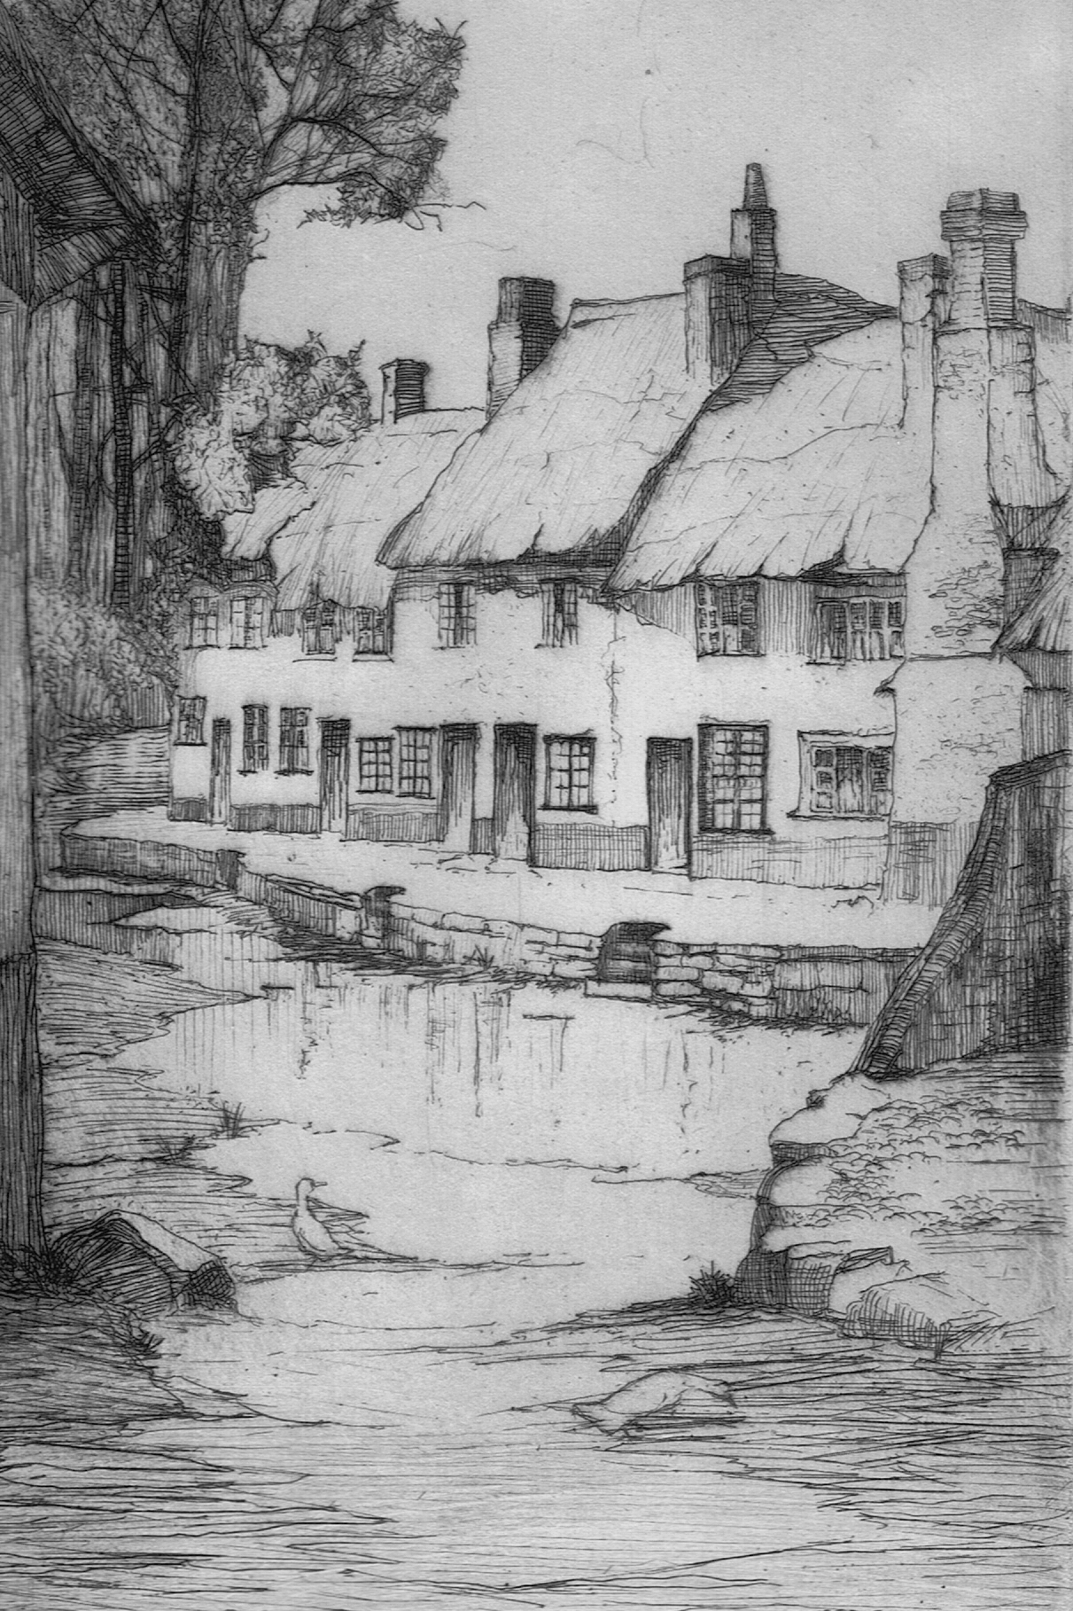 **Ide Community Orchard – Guidelines for Use**

1. The Orchard is a great place to observe our local wildlife. Please show respect for the plants and animals that live here, and take care of the young trees.
2. The Orchard is open to you every day of the year from dawn until dusk, but is closed from 10 pm. We will give lots of notice when access to all or parts of the Orchard may be restricted for short periods of time to allow for essential maintenance, grass cutting or grazing.
3. You are welcome to walk your dog in the Orchard, but please exercise close control at all times and clean up after you, using the poo bins at the entrance to the Orchard. Commercial dog walkers are not permitted to exercise their dogs in the Orchard.
4. The Orchard is not suitable or safe for cars or bikes.
5. Please do use your Orchard for picnics etc. There are picnic tables at various locations in the Orchard. Barbecues are fine but please do take care to avoid fire and take your litter home with you.

